Unit #1~ Age of Exploration

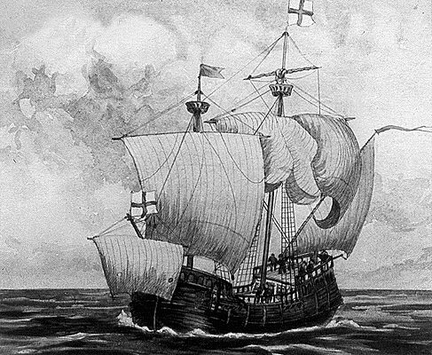
Define:
- The Silk Road
- Crusades
- Circumnavigate
- Christopher Columbus
- Ferdinand Magellan
- Prince Henry the Navigator
- Vasco de Gama
- Giovanni Verrazano

Questions to Answer:

What was the main driving force that allowed the Age of Exploration to happen?
- A desire to spread Christianity
- Development of better ship and map technology
- Kings offered to support explorers voyages
- The fall of the Roman Empire

During the Age of Exploration, Europeans were able to make longer, safer voyages because of improvements in what area?
- Sails
- clothing
- food preservation
- map-making

Unit #2~ Age of Colonization
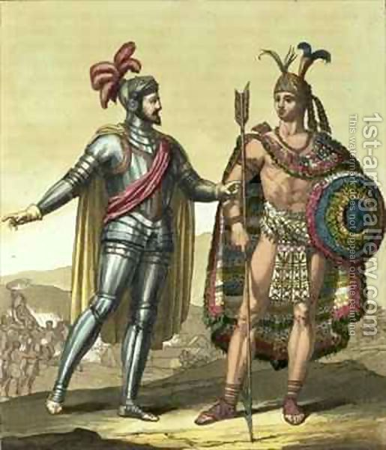

Define:
- Triangular Trade
- New World
- Old World
- Encomienda
- Middle Passages
- Conquistadores
- Land colonized by the French
- Land colonized by the English
- Land colonized by the Spanish
- Mercantilism
- Columbian Exchange

Answer:

Which of following was a major political motive for the English to colonize?
  - Colonists were opposed to the monarchy of England and wanted more political freedoms.
  - To obtain raw materials in making new products for trade.
  - To avoid paying taxes that other countries made them pay during trade.

Which of the following describes the economic motives for the English to colonization?
- Colonists were opposed to the monarchy of England and wanted more political freedoms.
- To obtain raw materials to use in making new products for trade.
- To be able to practice religion without being harassed.

Unit #3~ Absolutism and Enlightenment

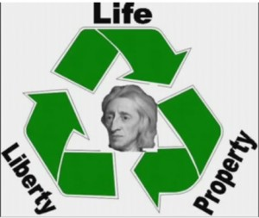
Define:
- Absolutism
- Enlightenment
- Salons (NOT where you get your hair styled…)
- Beliefs of the following Enlightenment Thinkers:
  - John Locke
  - Baron de Montesquieu
  - Cesare Beccaria
  - Thomas Hobbes
  - Voltaire
- French and Indian War

Answer:

Many important figures of the Enlightenment believed in Deism, which was…
- the belief that there were many gods and goddesses
- the belief that god created the world and then stepped back and does not interfere.
- the belief that god chose the king to be the ruler over a country.
- the belief that there was no god at all.

Philosophers in this country gathered in salons and debated ideas about government.
a. United States b. Germany c. France D. Canada

Which answer below is an example of Absolutism?
- Power divided among 3 branches of government
- All the power of a country in the hands of a single monarch
- People being born with natural rights
- A ruling family passing down power from one generation to another

Unit #4~ Revolutions

Define:
- Monarchy
- Democracy
- Divine Right of Kings
- First Estate, Second Estate, Third Estate
- Napoleon Bonaparte
- Highlights from the Following Events:
  - American Revolution
  - French Revolution (think of Reign of Terror, Tennis Court Oath, Storming of the Bastille, etc.)

Answer:

What effect did the American Revolution have on the French Revolution?
- It led French Revolutionaries to establish a system of government with three branches.
- It led the revolutionary French government to grant freedom to their colonies in America.
- It made the idea of a democracy popular and helped to bankrupt the French government.
- It caused the French government to declare war on Great Britain.
Which of the following reasons below IS NOT a similarity between the American and French Revolutions?
- They both were inspired by Enlightenment ideas.
- Commanding generals from each army became leaders of the new governments
- Declarations of Independence were written in both.
- They were both fighting against the tyranny of abusive governments.

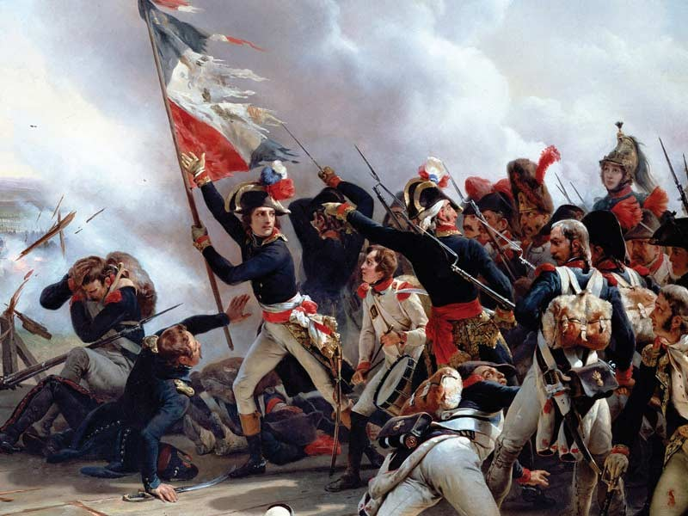

Unit #5~ Rise of Nations

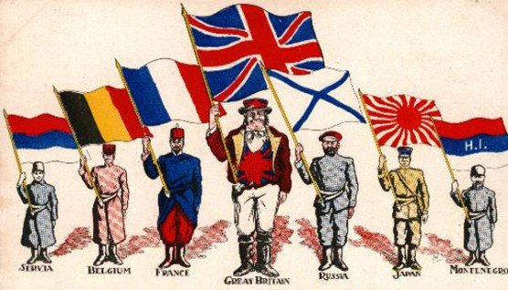
Define:
- Industrialism
  - Industrial Revolution
- Nationalism
- Imperialism
  - Berlin Conference of 1884
  - Social Darwinism
  - The Opium War
  - The key players in “the Scramble for Africa”

Answer:

Which of the following is the BEST social reason for European Imperialism in Africa
- raw goods b. mercantilism c. spread Christianity d. wealth and power

“They all originated in political ambitions…the nations’ will to power…[or] glory or national greatness.” How does this quote best describe the European view of Imperialism?
- A decrease in nationalism caused governments to explore Africa.
  - The European countries were all seeking to be the most powerful.
  - The European countries were all fighting to create the best trade routes
  - None of the above are correct.

What was the connection between the Industrial Revolution and the spread of Imperialism?
  - European nations gave natural resources to factories in Africa.
  - Countries were seeking out natural resources to use.
  - There was no connection between them.
  - The quest for resources lead to more cooperation between countries.

Distinguish which of the following was a major cause of the Industrial Revolution.
  - Population growth meant there was a greater demand for goods.
  - A need for more advanced farming methods and techniques was spreading.
  - There was a demand for items to be produced quickly and in mass amounts.
  - All of the above are causes of the Industrial Revolution.

Unit #6~ World War I
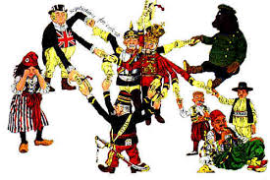
Define:
- Militarism
- Alliances
- Nationalism
- Imperialism
- Assassination
- Triple Alliance
- Triple Entente
- Central Powers
- Allied Powers

Answer:

What was the “spark” that immediately caused World War I?
  - The alliance that was made between Britain, France, and Russia.
  - The assassination of an Austrian nobleman.
  - Longstanding tensions between France and Germany.
  - The sinking if a ship called the Lusitania.

Why might it be inferred that the Triple Entente was not a strong alliance?
- The alliance was made up of former enemies.
- Only France was concerned about Germany’s plans to dominate Europe.
- They were all in competition with each other for colonies.
- both a and c are correct.

What was a result of all the new technologies introduced during WWI?
- They made the war much shorter than earlier wars.
- The made it easier for the allies to advance through Germany.
- They made it easier to kill and wound more soldiers than ever before.
- They allowed Germany to take France easily.

Unit #7~ Between the Wars & World War II

Define:
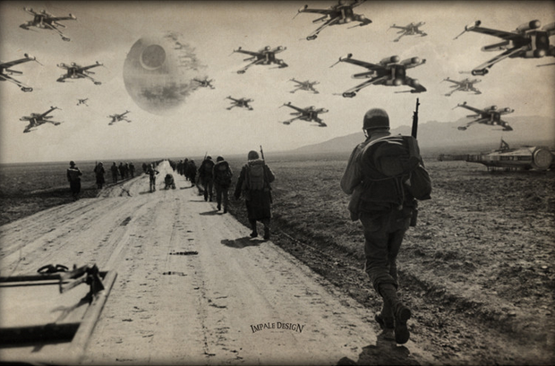
- The Great Depression
- Treaty of Versailles
- Wilson’s 14 Points
- League of Nations
- Allied Powers (Countries and their leaders)
- Axis Powers (Countries and their leaders)
- Propaganda
- The Holocaust
- Kristallnacht
- Hitler Youth
- The Impact of the Atomic Bomb

Answer:

Which of the following statements describes why Hitler and the Nazi party were able to rise to and keep his power so easily?
  - Germany was looking for new leadership because they were humiliated by the Treaty of Versailles.
  - Hitler used secret police to spy on people and uncover their enemies.
  - The Nazi party was able to take away freedom from individuals including their freedom of speech and press.
  - All of the above are accurate statements.

Which of the following is NOT considered a failure of the League of Nations?
  - The United States overpowered League of Nations meetings.
  - The treaties were too harsh and the League had trouble imposing them.
  - Nations continued to colonize despite the League’s terms and stipulations.
  - The League met too infrequently
Unit #8~ New Nations Emerge
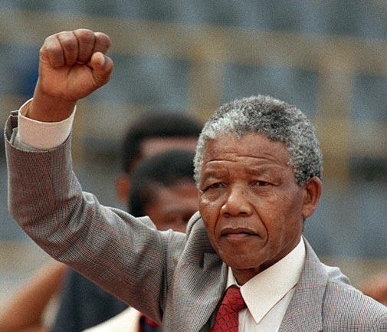

Define:
- United Nations
- Palestine (Palestinian Arabs)
- Israel (Jewish Israelis)
- Zionism
- Pan-Africanism
- Decolonization
- Mahatma Gandhi
- Nelson Mandela

Answer:

Which of the following is a key to success of a nonviolent action?
- Banning Olympic athletes
- Having a largely supported issue
- Picketing and singing songs
- Walking off the job site

From which European nation did both India and South Africa want to break ties?
- Great Britain
- Russia
- France
- Germany

Europeans often justified colonization using the concept of the ____________, an obligation to "civilize" the peoples of Africa.
- Pan-Africanism
- White Man’s Burden
- Zionism
- Colonization
Unit #9~ The Cold War
Define:
- Capitalism (With examples of countries and their leaders)
- Communism (With examples of countries and their leaders)
- The Marshall Plan
- The Iron Curtain
- Containment
- Cold War
- Hot War
- Truman Doctrine
- Korean War
- Demilitarized Zone (DMZ)
- Space Race
- Vietnam War
- Cuban Missile Crisis

Answer:
How was the U.S. involvement in the Vietnam War similar to that of the Korean War?
- The U.S. became involved because nuclear missiles were discovered
- The U.S. became involved to “contain” the spread of communism
- The U.S. became involved to take the areas as new American colonies
- The U.S. became involved to eliminate the possibility of of war on U.S. soil
The tension that existed between the United States and the Soviet Union was primarily caused by…
- The competition of two ideologies; democracy versus communism
- Both countries desired to have absolute control over Korea and Vietnam
- Wanting to stop other countries around the world from having a space program
- The competition over who could be known for rebuilding Europe

Unit #10~ Make A Difference
Define:
- Human Rights
- Humanitarian Aid
- Minimum Wage
- “The Have’s and Have Not’s”
- Apartheid
- Globalization
- Universal Declaration of Human Rights
- Integration
- Gross Domestic Product (GDP)

Answer
Analyze the following quote: “You can’t stop business from going global, but you can make it listen to the responsibilities that go with jumping onto the globalization bandwagon. “~ Anita Roddick, British businesswoman and activist. The structure of this idea would best be described as...
  - descriptive c. chronological
  - cause and effect d. compare and contrast
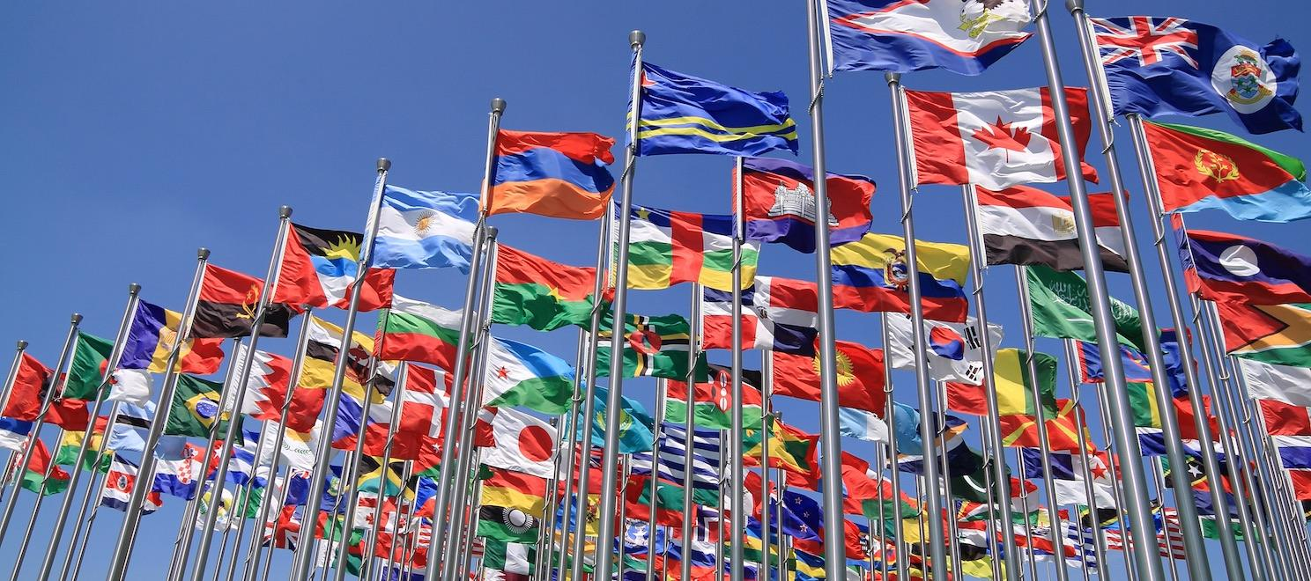

Unit #11~ The World Today

Define:
- Conflict Minerals
- Casino Economy
- AIDS Epidemic
- Child Soldiers
- Genocide
- China’s One Child Policy

Answer:
None for this one… CELEBRATe!!!!!
